**System Requirement Specification (SRS)**

Version 1

July 25, 2019

**Flight Ticket Booking (FTB)**

by

Chibuisi Kelvin Amiaka

Ali Mohammad Ahmadi

Submitted in partial fulfillment of requirement of Software Engineering

Contents

1. Use Cases 1

1.1. Use Case Diagram 1

1.2. Use Case Descriptions 2

2. Supplementary requirements 8

2.1. Reliability 8

2.2. Performance 8

2.3. Security 8

3. Glossary 9

4. Github Link 9

# 1. Use Cases

## 1.1. Use Case Diagram

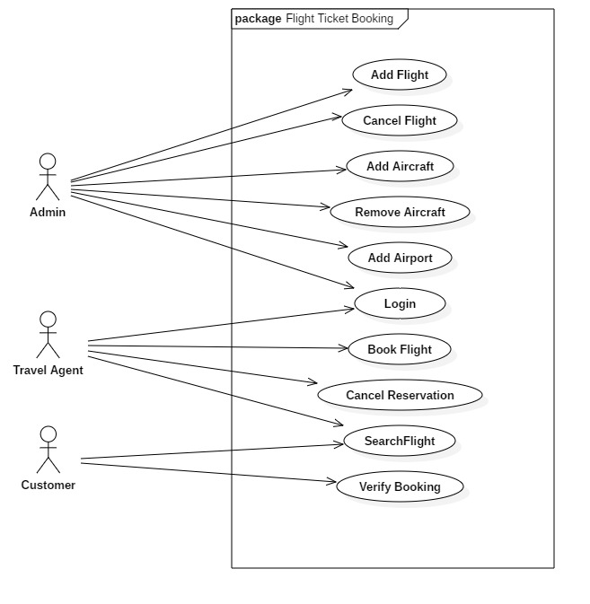

## 1.2. Use Case Descriptions

|  |  |  |
| --- | --- | --- |
| Add New Flight | | |
| Brief Description: | Adding information about new flight to the system | |
| Actor | Admin | |
|  |  |  |
| Preconditions | | |
| The admin must be logged into the system | | |
| Flow of Events | | |
| Basic Flow | | |
| Steps | User Actions | System Actions |
| 1 | Clicks on add flight button | Add new flight page will open which includes a new flight form |
| 2 | Admin enters the new flight information into the system by providing flight number, flight departure, flight destination, flight charge, flight date, aircraft, and airport | System checks if there is not duplication of same flight number and then saves the new flight into the system |
| Postconditions | | |
| New flight will be added to the system | | |
| Business Rules | | |
| Flight number should not be duplicate | | |
| Alternative Path | | |
| 1 | Flight number exist | System shows message for the duplicate flight, and can not add this to the system |

|  |  |  |
| --- | --- | --- |
| Cancel Flight | | |
| Brief Description: | Remove flight from the system | |
| Actor | Admin | |
|  |  |  |
| Preconditions | | |
| The admin must be logged into the system | | |
| Flow of Events | | |
| Basic Flow | | |
| Steps | User Actions | System Actions |
| 1 | Clicks on Delete flight button | System will ask for the fight number |
| 2 | User provides the flight number | System will show the flight information to the interface |
| 3 | User click remove button | System will remove the flight from the system |
| Postconditions | | |
| The flight will be removed from the system | | |
| Business Rules | | |
| User should provide available flight number | | |
| Alternative Path | | |
| 1 | Flight number is not in the system | System shows warning message that flight does not exist |

|  |  |  |
| --- | --- | --- |
| Add Aircraft | | |
| Brief Description: | Add aircraft to the system | |
| Actor | Admin | |
|  |  |  |
| Preconditions | | |
| The admin must be logged into the system | | |
| Flow of Events | | |
| Basic Flow | | |
| Steps | User Actions | System Actions |
| 1 | Clicks on add aircraft | System will show a form to fill aircraft information |
| 2 | User fills the aircraft information like id, manufacturer, model, and number of seats and hits save button | System will save the aircraft into the system |
| Postconditions | | |
| The aircraft will be added to the system | | |
| Business Rules | | |
| User should fill all field of the form | | |
| Alternative Path | | |
| 1 | Form is not filled completely | System shows warning message that provide all required fields |

|  |  |  |
| --- | --- | --- |
| Remove Aircraft | | |
| Brief Description: | Remove aircraft from the system | |
| Actor | Admin | |
|  |  |  |
| Preconditions | | |
| The admin must be logged into the system | | |
| Flow of Events | | |
| Basic Flow | | |
| Steps | User Actions | System Actions |
| 1 | Clicks on Delete aircraft button | System will ask for the aircraft id |
| 2 | User provides the aircraft id | System will show the aircraft information to the interface |
| 3 | User click remove button | System will remove the aircraft from the system |
| Postconditions | | |
| The aircraft will be removed from the system | | |
| Business Rules | | |
| User should provide available aircraft number | | |
| Alternative Path | | |
| 1 | Aircraft with provided id is not in the system | System shows warning message that aircraft does not exist |

|  |  |  |
| --- | --- | --- |
| Add Airport | | |
| Brief Description: | Add airport to the system | |
| Actor | Admin | |
|  |  |  |
| Preconditions | | |
| The admin must be logged into the system | | |
| Flow of Events | | |
| Basic Flow | | |
| Steps | User Actions | System Actions |
| 1 | Clicks on add airport button | System will show a form to fill airport information |
| 2 | User fills the airport information like airport code, city, state, country and hit save button | System will save the airport into the system |
| Postconditions | | |
| The airport will be added to the system | | |
| Business Rules | | |
| User should fill all field of the form | | |
| Alternative Path | | |
| 1 | Form is not filled completely | System shows warning message that provide all required fields |

|  |  |  |
| --- | --- | --- |
| Login | | |
| Brief Description: | Log in to the system | |
| Actor | Admin, Travel agent | |
|  |  |  |
| Preconditions | | |
| The user must be logged into the system | | |
| Flow of Events | | |
| Basic Flow | | |
| Steps | User Actions | System Actions |
| 1 | Fill the username and password field and hit login | System will authenticate the user and grant access level authorization to the user, and forward it to the main panel |
| Postconditions | | |
| The user is logged in | | |
| Business Rules | | |
| Username and password is incorrect / User not found | | |
| Alternative Path | | |
| 1 | Authentication error | System will show that either username or password is not correct |

|  |  |  |
| --- | --- | --- |
| Search Flights | | |
| Brief Description: | Searching flights from specific airport to specific airport and specific date | |
| Actor | Travel agent, Customer | |
|  |  |  |
| Preconditions | | |
| The travel agent must be logged into the system | | |
| Flow of Events | | |
| Basic Flow | | |
| Steps | User Actions | System Actions |
| 1 | Fills the departure and destination airport and selects a date | System will search through the flights and will show the flights available for that specific date and show to the interface |
| Postconditions | | |
| List of available flights will be shown to the interface | | |
| Business Rules | | |
| No flight found | | |
| Alternative Path | | |
| 1 | No flight found | System will show a message that no flight is found for that date from departure airport to destination airport |

|  |  |  |
| --- | --- | --- |
| Book Flight | | |
| Brief Description: | Book flight for a customer for specific date | |
| Actor | Travel agent | |
|  |  |  |
| Preconditions | | |
| The travel agent must be logged into the system, and already searched for flights and a list of flights (or flight) are available to book | | |
| Flow of Events | | |
| Basic Flow | | |
| Steps | User Actions | System Actions |
| 1 | Travel agent will select a specific flight from the list of available flight for desired date and hit book button | System will ask the user to provide the customer information |
| 2 | User will fill required information about the customer like name, address, phone number, and passport number and hit save button | System will reserve a seat in flight for the customer and will show ticket to the interface which will be given to the customer |
| Postconditions | | |
| A sit in the flight will be reserved/booked for the customer | | |
| Business Rules | | |
| Customer information should be filled completely | | |
| Alternative Path | | |
| 1 | Form is not filled completely | System shows warning message that provide all required fields |

|  |  |  |
| --- | --- | --- |
| Cancel Reservation | | |
| Brief Description: | Remove booked seat from the flight | |
| Actor | Admin | |
|  |  |  |
| Preconditions | | |
| The admin must be logged into the system | | |
| Flow of Events | | |
| Basic Flow | | |
| Steps | User Actions | System Actions |
| 1 | Clicks on cancel reservation button | System will ask for the reservation id |
| 2 | User provides the reservation id | System will find the flight information and show to the interface |
| 3 | User click cancel reservation button | System will cancel reserved seat from the flight |
| Postconditions | | |
| The reserved seat will be removed from the flight | | |
| Business Rules | | |
| User should provide valid reservation id | | |
| Alternative Path | | |
| 1 | Reservation id not found | System shows warning message that no reservation found |
| Verify Booking | | |
| Brief Description: | Verify and check the booked flight | |
| Actor | Customer | |
|  |  |  |
| Preconditions | | |
| The customer already booked a flight and have the ticket with reservation id | | |
| Flow of Events | | |
| Basic Flow | | |
| Steps | User Actions | System Actions |
| 1 | Clicks on verify booking button | System will ask for the reservation id |
| 2 | User provides the reservation id | System will find the flight information and show to the interface |
| Postconditions | | |
| The customer will see the his/her booked flight information | | |
| Business Rules | | |
| User should provide valid reservation id | | |
| Alternative Path | | |
| 1 | Reservation id not found | System shows warning message that no reservation found |

# 2. Supplementary requirements

## 2.1. Reliability

The system must be running 98% of the time.

## 2.2. Performance

The Flight Ticket Booking System will be on a server with high speed Internet capability. The software developed here assumes the use of a tool such as Tomcat for connection between the Web pages and the database. The system will support up to 1000 simultaneous users working with the central database.

## 2.3. Security

The system is secured, and admin and travel agents should authenticate to access the system. But the customers can access information about flights anytime.

# 3. Glossary

|  |  |  |
| --- | --- | --- |
| **No** | **Term** | **Definition** |
| 1 | Admin | Is the person responsible to manage system including adding and removing items into the system like flight, aircraft, airport and etc. |
| 2 | Travel Agent | Is the person who is responsible to find a flight for the customers and book flight for them |
| 3 | Customer | Is the person who is going to travel and wants to book a flight and buy a ticket |
| 4 | Flight | Flight is a scheduled travel from one place to another which will happen in a certain time and location to another location with specific aircraft with specific number of passengers |
| 5 | Aircraft | Is the airplane which is going to be assigned for a specific flight |
| 6 | Airport | Is a place which flight will be from or to |
| 7 | Booking Flight | Reserving a seat of aircraft which is flying from specific airport to another |
| 8 | Cancel Reservation | Canceling the reservation for a flight |
| 9 | Search Flight | Searching how many flights are available for specific date from specific airport to another |
| 10 | Verify Booking | When customers book a flight, they can verify their flight by reservation id inside ticket which they got from the travel agent |

# 4. Github Link

https://github.com/alimohammadahmadi/FlightBookingSystem.git